Title: Technical Documentation – GUI-Based A* Pathfinding Simulator in Python

Course: [Introduction to Artificial Intelligence]
Group Members:
Adham Sobhy 23-101003
Yassin Farrag 23-101019
Andrew Emad 23-101092
Belal Mohamed 23-101061
Ahmed Tamer 23-101116
Mohamed Maged 23-101293

Contents
Abstract 4
System Overview 4
Problem Definition 5
Technologies and Requirements 6
Methodology 6
Phase 1 – Problem Analysis and Design (current phase) 6
Phase 2 – Prototype Implementation 7
Phase 3 – Refinement, Comparison, and Experimentation 7
High-Level Architecture 8
Data Structures 8
Grid and Cell Representation 8
Node Representation in A* 9
Open and Closed Sets 9
A* Algorithm Details 9
A* Principle 9
Heuristics 10
Algorithm Steps (Conceptual) 10
Planned AI Search Algorithms 11
A* Search (Informed Search) 11
Dijkstra’s Algorithm (Uniform-Cost Search) 11
Greedy Best-First Search (Heuristic-Only) 12
Breadth-First Search (BFS) 12
Depth-First Search (DFS) 12
Bidirectional Search (Optional Extension) 13
GUI Design and Interaction 13
Layout 13
User Actions 14
Execution Flow 15
Full Project Pipeline 16
User and Data Input 16
Preprocessing and Initialization 16
Algorithm Execution 17
Visualization and Interaction Loop 17
Output and Evaluation 17
Iterative Experimentation 17
Performance and Complexity 18
Testing and Validation 18
How to Run the Application 19
Team Roles and Understanding 19
Flowchart 21

Abstract
This document presents the design and Phase 1 planning of a GUI-based pathfinding simulator for an Introduction to Artificial Intelligence course. The system focuses on visualizing and comparing multiple informed and uninformed search algorithms on a grid-based environment. Users will be able to interactively define start and goal positions, place obstacles, and observe how different algorithms explore the space and construct paths. The documentation describes the problem definition, selected AI search algorithms, methodology, project pipeline, system architecture, and team working plan. No implementation is required at this phase; instead, we provide a clear blueprint that demonstrates the technical feasibility and educational value of the proposed simulator.

System Overview
This document describes the design, architecture, algorithms, and usage of our GUI-based A* pathfinding simulator implemented in Python.
The system allows users to:
- Interactively build or edit a grid map.
- Choose start and goal cells.
- Run the A* search algorithm and watch its progress step by step.
- View metrics such as path cost, number of expanded nodes, and running time.
The application is structured into clearly separated components to keep the logic understandable for all group members.

Problem Definition
The core problem addressed by this project is the difficulty that students face in understanding search and pathfinding algorithms when they are presented only as formulas and pseudocode. Given a grid-based environment with obstacles, a start cell, and a goal cell, the task is to find a valid path—preferably an optimal or near-optimal one—while clearly showing how the algorithm explores the state space.

More formally, the problem can be stated as follows:
Given:
- A finite 2D grid composed of cells.
- A subset of cells marked as obstacles (non-traversable).
- A designated start cell and a goal cell.

Find:
- A sequence of valid moves from the start cell to the goal cell such that:
- All intermediate cells are within the grid and not obstacles.
- The total cost of the path is minimized (for optimal algorithms).

Constraints:
- The visualization must run interactively and at an educational scale (e.g., up to 50x50 grids).
- Users should be able to configure the environment and algorithm choice without writing code.

The simulator aims not only to solve the pathfinding problem but to make each step of the solution process visible and understandable to introductory AI students.

Technologies and Requirements
- Programming Language: Python 3.x
- GUI Library: [Tkinter or Pygame – choose one and adjust text accordingly]
- Operating System: Any OS that supports Python 3 (tested on [Windows / Linux / macOS]).
Python dependencies (typical):
- Standard Library:
  - tkinter (or pygame if using Pygame).
  - time for timing.
  - heapq for priority queues.
  - math for heuristic calculations (if using Euclidean distance).
No external third-party packages are strictly required, which makes the project easy to set up and run.

Methodology
Our methodology for the project is organized into clear phases, with a strong focus on planning and understanding before implementation, as required in Phase 1:

Phase 1 – Problem Analysis and Design (current phase)
  - Clarify and formalize the problem definition (grid-based pathfinding and educational visualization).
  - Review relevant AI search algorithms (e.g., A*, Dijkstra, Greedy Best-First, BFS, DFS, Bidirectional Search) and select those to be included.
  - Define evaluation criteria: path optimality, number of expanded nodes, execution time, and clarity of visualization.
  - Design the system architecture and data structures without writing production code.
  - Specify the GUI behavior, user interactions, and visualization conventions.
  - Produce complete documentation of the planned algorithms, pipeline, and team responsibilities.

Phase 2 – Prototype Implementation
  - Implement the grid and cell data structures.
  - Implement the core search algorithms according to the specifications in this document.
  - Implement a basic GUI that can display the grid and update it step by step.
  - Integrate timing and metrics collection (expanded nodes, path length, etc.).
  - Perform functional tests on small grid scenarios.

Phase 3 – Refinement, Comparison, and Experimentation
- Add support for switching between algorithms on the same map for visual comparison.
- Perform systematic tests to compare algorithms with respect to:
- Optimality of paths
- Number of expanded nodes
- Execution time
- Improve the user experience (e.g., clearer colors, labels, speed controls).
- Refine documentation with experimental results and lessons learned.

This phased methodology ensures that the project moves from a solid conceptual foundation (Phase 1) to a working educational tool (Phase 2 and Phase 3) while keeping all team members aligned on their responsibilities.

High-Level Architecture
The project is organized conceptually into the following modules (file names may vary in the actual implementation):
- main.py
  - Entry point of the application.
  - Initializes the GUI window and the main components.
- grid.py
  - Contains classes for the grid and cells.
  - Manages state of each cell (empty, obstacle, start, goal, explored, etc.).
- algorithms.py
  - Implements the A* search algorithm (and optionally other search algorithms).
  - Exposes functions that can be called by the GUI to run or step through the algorithm.
- gui.py
  - Contains the GUI logic and event handlers.
  - Renders the grid, handles mouse clicks, buttons (Start, Pause, Reset, Step), and updates display.
The architecture follows a separation of concerns approach:
- The algorithm logic is independent from the GUI code.
- The grid data structure is shared between the algorithm and the GUI.
- The GUI regularly updates its display based on the current algorithm state.

Data Structures

Grid and Cell Representation
- The grid is represented as a 2D array/list of Cell objects.
- Each Cell stores:
  - Grid coordinates (row, column).
  - Type: empty, obstacle, start, goal.
  - For visualization: color or state flag (unvisited, frontier, explored, path).
This structure is simple and efficient for grid-based pathfinding.

Node Representation in A*
Each node in the search corresponds to a specific cell in the grid and stores:
- Position: (row, col).
- g = cost from the start node to this node.
- h = heuristic estimate to the goal.
- f = g + h.
- parent = reference to the previous node on the best-known path.
This representation allows us to easily reconstruct the final path once the goal is reached.

Open and Closed Sets
- Open Set (Frontier):
Implemented as a priority queue (often using heapq in Python), ordered by f value.
Stores nodes that have been discovered but not yet expanded.
- Closed Set (Explored):
Usually a set or dictionary that stores nodes that have already been processed.
Prevents re-expansion of the same position and improves performance.

A* Algorithm Details

A* Principle
The A* algorithm selects at each step the node with the lowest estimated total cost:
f(n) = g(n) + h(n)
where:
- g(n) is the actual distance from the start node to n.
- h(n) is a heuristic estimate from n to the goal.

Heuristics
We support at least one of the following heuristics:
- Manhattan Distance (for 4-directional movement):
h(n) = |x1 - x2| + |y1 - y2|
- Euclidean Distance (optional):
h(n) = sqrt((x1 - x2)^2 + (y1 - y2)^2)
The user can choose the heuristic from a dropdown menu in the GUI. This helps them see how different heuristics change the search behavior.

Algorithm Steps (Conceptual)
- Initialize the open set with the start node.
- Set g(start) = 0 and compute h(start) and f(start).
- While the open set is not empty:
  - Extract the node n from the open set with the lowest f.
  - If n is the goal, reconstruct and return the path.
  - Otherwise, move n to the closed set.
  - For each valid neighbor m of n (not an obstacle and inside the grid):
    - Compute tentative g(m) = g(n) + cost(n, m).
    - If m is not in open or closed, or the new g(m) is smaller than the old one:
      - Update parent(m) = n.
      - Recompute h(m) and f(m).
      - Add or update m in the open set.
- If the open set becomes empty and the goal was not reached, no path exists.
The GUI version executes these steps either continuously or one step at a time when the user clicks the Step button.

Planned AI Search Algorithms

To satisfy the course requirement and to allow meaningful comparisons, we plan to implement and visualize at least six AI search algorithms. All algorithms operate on the same grid representation and user interface.

A* Search (Informed Search)
Why chosen:
- A* is a standard informed search algorithm taught in introductory AI courses.
- It combines path cost and heuristic estimates, making it ideal for demonstrating the effect of heuristics.

How it helps solve the problem:
- Produces optimal paths when the heuristic is admissible.
- Its open/closed set behavior and f = g + h formulation are very instructive when visualized.

Dijkstra’s Algorithm (Uniform-Cost Search)
Why chosen:
  - Dijkstra’s algorithm is a classic optimal pathfinding algorithm that does not use a heuristic.
  - It serves as a baseline to compare with A* when all movement costs are non-negative.

How it helps solve the problem:
- Finds the lowest-cost path purely based on accumulated cost g.
- Allows students to see how adding a heuristic (A*) changes the exploration pattern and efficiency.

Greedy Best-First Search (Heuristic-Only)
Why chosen:
- Greedy Best-First Search uses only the heuristic h and ignores the path cost g.
- It is conceptually simple and often fast, but not guaranteed to find optimal paths.

How it helps solve the problem:
- Highlights the trade-off between speed and optimality.
- When visualized, it shows strong “goal-directed” behavior that may get stuck in local minima or suboptimal routes, which is useful for teaching.

Breadth-First Search (BFS)
Why chosen:
- BFS is a fundamental uninformed search algorithm.
- On unweighted grids, it finds the shortest path in terms of number of steps.

How it helps solve the problem:
- Acts as a simple baseline without heuristics or varying costs.
- Its layer-by-layer expansion is easy to visualize and understand, especially on small grids.

Depth-First Search (DFS)
Why chosen:
- DFS is another core uninformed algorithm, often taught alongside BFS.
- It has very different search behavior, exploring deeply along one path before backtracking.

How it helps solve the problem:
- When visualized, DFS clearly contrasts with BFS and A*-like algorithms.
- It helps students understand why DFS is usually not preferred for shortest-path problems, even though it is memory-efficient.

Bidirectional Search (Optional Extension)
Why chosen:
- Bidirectional search is an advanced technique that simultaneously searches forward from the start and backward from the goal.
- It can greatly reduce search time when applicable.

How it helps solve the problem:
- Demonstrates the idea of meeting in the middle to reduce search depth.
- When visualized, it shows two frontiers growing towards each other, which is conceptually powerful for students.

Each of these algorithms will share the same grid and GUI components, allowing direct, fair comparison of their exploration patterns, path quality, and performance metrics.

GUI Design and Interaction

Layout
The user interface generally contains:
- Grid Canvas:
A 2D drawing area where each cell is drawn as a square. Colors indicate:
  - Empty cells.
  - Obstacles.
  - Start cell.
  - Goal cell.
  - Frontier nodes.
  - Explored nodes.
  - Final path.
- Control Panel:
Buttons and controls such as:
  - Start: Begin or resume the algorithm execution.
  - Pause: Temporarily stop the animation.
  - Step: Execute exactly one A* iteration.
  - Reset: Clear the grid and algorithm state.
  - Dropdown to select heuristic type.
  - Optional buttons to set grid size or randomly generate obstacles.
- Information Panel:
Labels to display:
  - Current algorithm state (Idle / Running / Paused / Finished).
  - Path cost of the current best solution.
  - Number of expanded nodes.
  - Execution time.

User Actions
- Placing Obstacles:
The user can click on cells to toggle them between empty and obstacle states before running A*.
- Setting Start and Goal:
The user can right-click or use a specific mode (e.g., a “Set Start” button) to choose start and goal cells.
- Running the Algorithm:
After setting up the grid, the user clicks Start. The GUI then:
  - Calls the A* function.
  - Updates the grid colors each step to show progress.
- Observing Metrics:
The user can watch the path being built and see final metrics once the goal is found.

Execution Flow
- Application Start:
  - main.py creates the main window and initializes the grid and GUI controls.
- Grid Setup:
  - User edits the grid (obstacles, start, goal).
  - GUI updates the grid representation in grid.py.
- Algorithm Initialization:
  - When the user presses Start, the GUI calls the A* initialization function in algorithms.py.
  - The open set is filled with the start node, and timers are reset.
- Main Loop / Step Execution:
  - Each “tick” or “step” of the animation:
    - Expands one node.
    - Updates open and closed sets.
    - Updates the corresponding cell colors in the GUI.
- Goal Reached or No Path:
  - If the goal is reached:
    - The algorithm reconstructs the path using the parent links.
    - The path is drawn on the grid.
    - Final metrics are shown.
  - If the open set becomes empty:
    - The GUI informs the user that no path exists.

Full Project Pipeline
This subsection summarizes the complete end-to-end pipeline of the project, from user input to algorithm execution and visualization.

User and Data Input
- The user specifies:
- Grid size (e.g., 10x10, 20x20, up to 50x50).
- Positions of obstacles (by clicking cells to toggle them).
- Start and goal cells.
- Chosen algorithm (A*, Dijkstra, Greedy Best-First, BFS, DFS, Bidirectional Search).
- Chosen heuristic (where applicable, e.g., Manhattan vs Euclidean distance).

Preprocessing and Initialization
- The system:
- Constructs an internal grid representation (2D array of cells).
- Validates that start and goal cells are within bounds and not obstacles.
- Initializes algorithm-specific data structures:
- Open and closed sets (for A*, Dijkstra, Greedy Best-First).
- Queues or stacks (for BFS, DFS).
- Resets metrics: number of expanded nodes, path cost, execution time.

Algorithm Execution
- The selected algorithm runs in discrete steps:
- At each step, it selects the next state (cell) to expand based on its strategy.
- It updates internal structures (frontier, visited/explored sets, parent pointers).
- It updates metrics (expanded nodes, partial path cost, etc.).

Visualization and Interaction Loop
- After each meaningful step:
- The GUI updates the colors of:
- Frontier nodes.
- Explored/visited nodes.
- Current node.
- Final path (once known).
- The user can:
- Pause or resume the execution.
- Step through the algorithm one iteration at a time.
- Reset the environment and choose a different algorithm or heuristic.

Output and Evaluation
- When a goal is found (or determined unreachable), the system:
- Highlights the final path on the grid (if it exists).
- Displays:
- Path length / total cost.
- Number of expanded nodes.
- Execution time.
- Optionally logs or exports statistics for later comparison between algorithms.

Iterative Experimentation
- The user may repeat the pipeline with:
- Different obstacle configurations.
- Different algorithms on the same map.
- Different heuristics (for algorithms that need them).
- This enables systematic comparison and deeper understanding of search behavior.

Performance and Complexity
- Time Complexity:
In the worst case, A* with a binary heap open set has time complexity O(E log V), where V is the number of nodes (cells) and E is the number of edges (connections between cells).
- Space Complexity:
The algorithm stores:
  - Open set.
  - Closed set.
  - Node data (g, h, f, parent).
In a typical grid (e.g., 50x50 = 2500 cells), this is easily manageable on standard computers. The main performance constraint is often the GUI refresh rate rather than the algorithm itself.

Testing and Validation
We tested the application through:
- Simple Straight-Line Tests:
No obstacles between start and goal to verify that A* produces a direct path with minimal cost.
- Maze-Like Obstacles:
Placing walls and barriers to ensure the path bends correctly around obstacles.
- No-Path Scenarios:
Surrounding the goal with obstacles to confirm that the algorithm correctly reports “no path”.
- Heuristic Comparison:
Running the same map with different heuristics (e.g., Manhattan vs. Euclidean) and comparing:
  - Number of nodes expanded.
  - Execution time.
  - Path optimality.
These tests show that the implementation behaves as expected and that the visualization accurately reflects the internal state of the algorithm.

How to Run the Application
- Install Python 3 on your system.
- Ensure that the required GUI library (Tkinter or Pygame) is available.
- Place all project files in the same folder (e.g., main.py, grid.py, gui.py, algorithms.py).
- Open a terminal or command prompt in that folder.
- Run the application using:
python main.py
- The main window of the A* Pathfinding Simulator will appear.
- Use the GUI to design the grid and run the algorithm.

Team Roles and Understanding
To ensure that all group members understand the code and logic, we divided the work as follows:
- Algorithm Design and Implementation:
One or more members focused on implementing and commenting the A* algorithm, including heuristics and data structures.
- GUI Design and Event Handling:
Another member focused on creating the interface, drawing the grid, and connecting buttons to algorithm functions.
- Integration and Testing:
All members participated in testing different scenarios, fixing bugs, and improving usability.
Throughout the project, we conducted code walkthroughs together, where we explained the logic function by function. As a result, every member can:
- Explain how A* works (including g, h, and f).
- Describe how the GUI triggers the algorithm.
- Interpret the visual output and performance metrics.

Flowchart
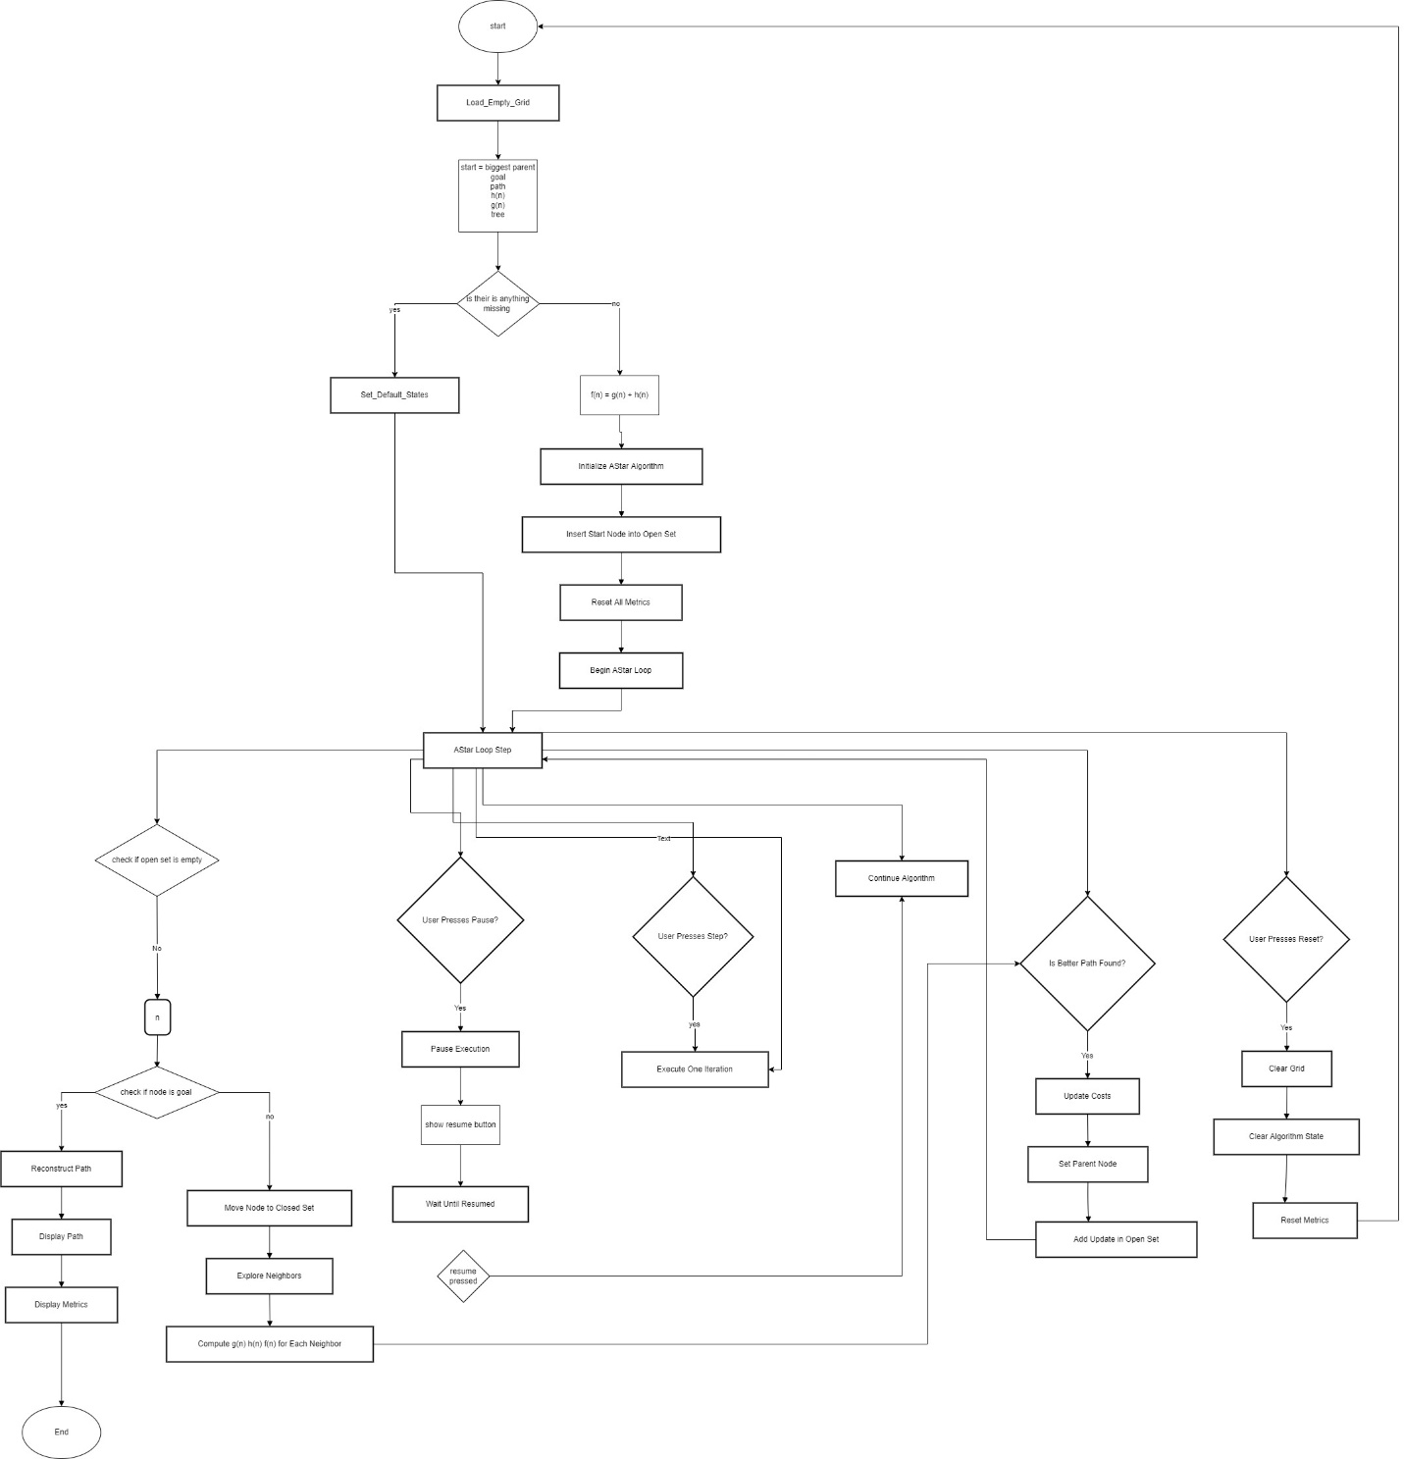

Figure A_ pathfinding game :

This flowchart summarizes the complete pipeline of the pathfinding simulator, from user configuration to algorithm execution and result visualization. The user first loads or creates an empty grid, selects the grid size, start and goal cells, obstacles, and the desired search algorithm (A*, Dijkstra, Greedy Best-First, BFS, DFS, or Bidirectional Search), as well as heuristic when required. The system then initializes the selected algorithm, its internal data structures (frontier / open set / queue / stack), and the performance metrics.

During the algorithm loop, the simulator repeatedly checks whether the frontier is empty (no-path case), selects the next node from the frontier, tests whether it is the goal, and, if not, explores its valid neighbors. For each neighbor it computes the appropriate cost and/or heuristic values and updates the frontier and visited sets if a better path is found. At any moment the user can pause, step through single iterations, continue, or reset and clear the grid. When a goal is found, the system reconstructs and displays the path along with the final metrics; if no path exists, it clearly reports this outcome together with the collected metrics.

